**41) create bucket-1(ap-south-1) and upload files(t1,t2,t3) into it**

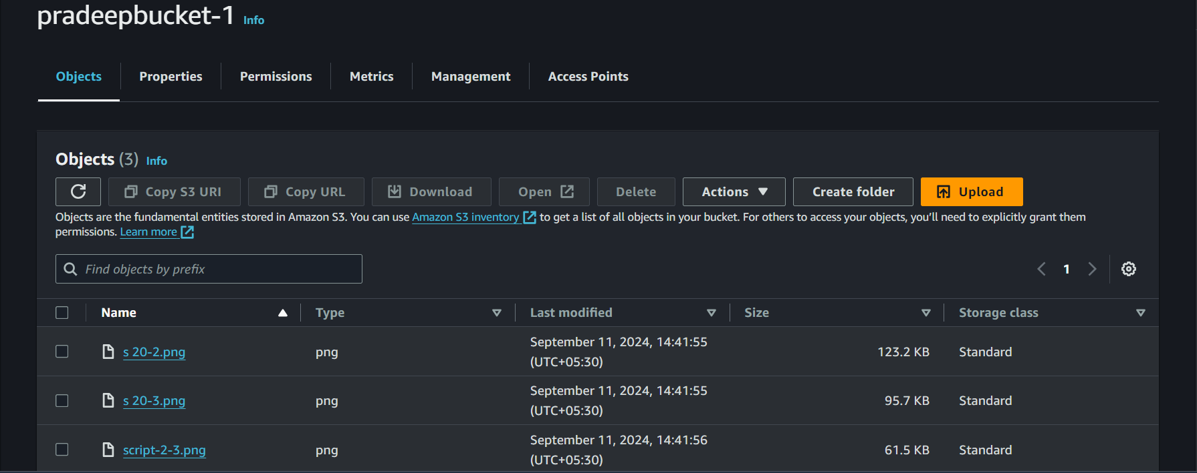

**42) Create bucket-2(ap-souht-1) and upload files(t4,t5,t6) into it**

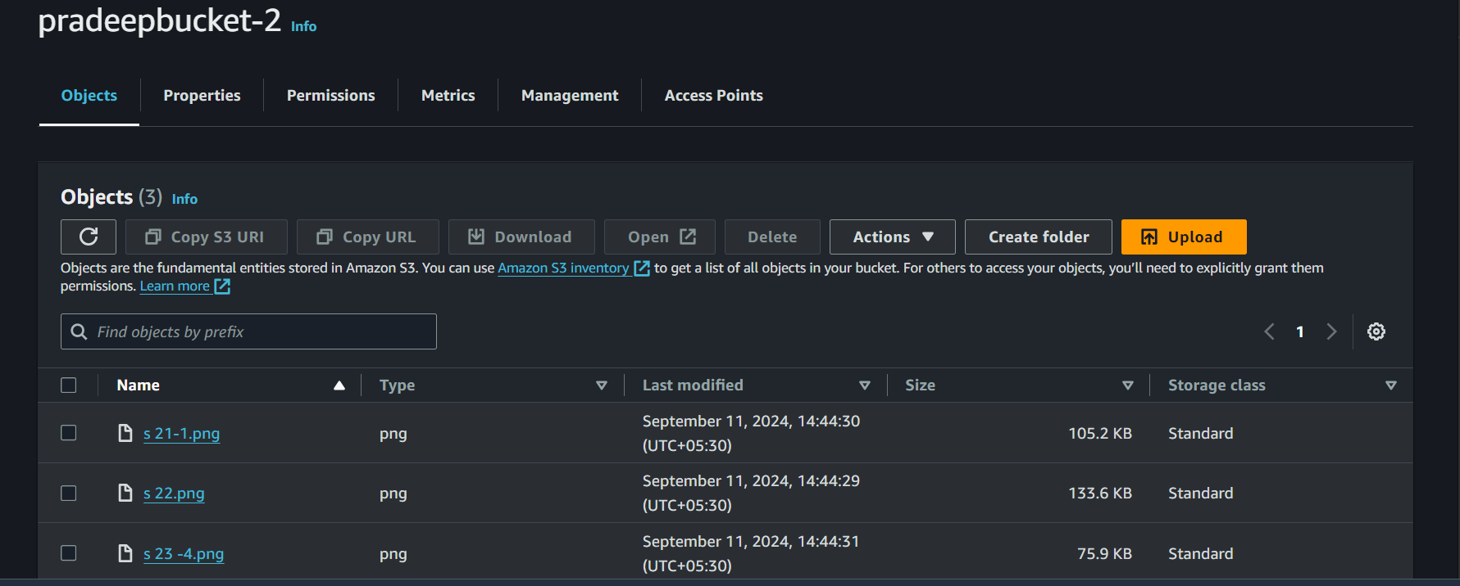

**43) Copy files from bucket-1 to bucket-2. so that bucket-2 should have all 6 files**

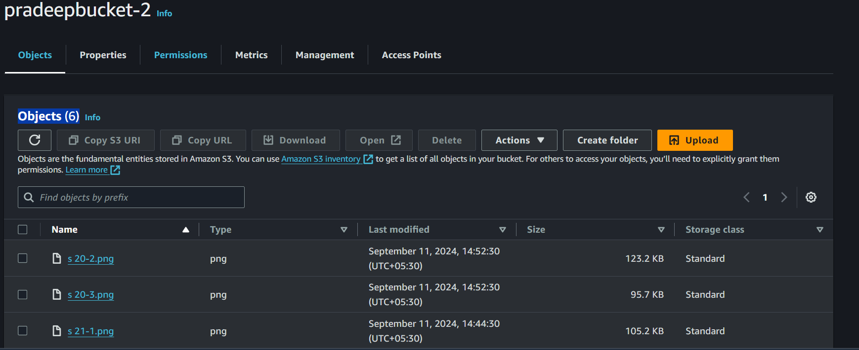

**44) Create bucket-3(us-east-1) and upload files(t7,t8,t9)**

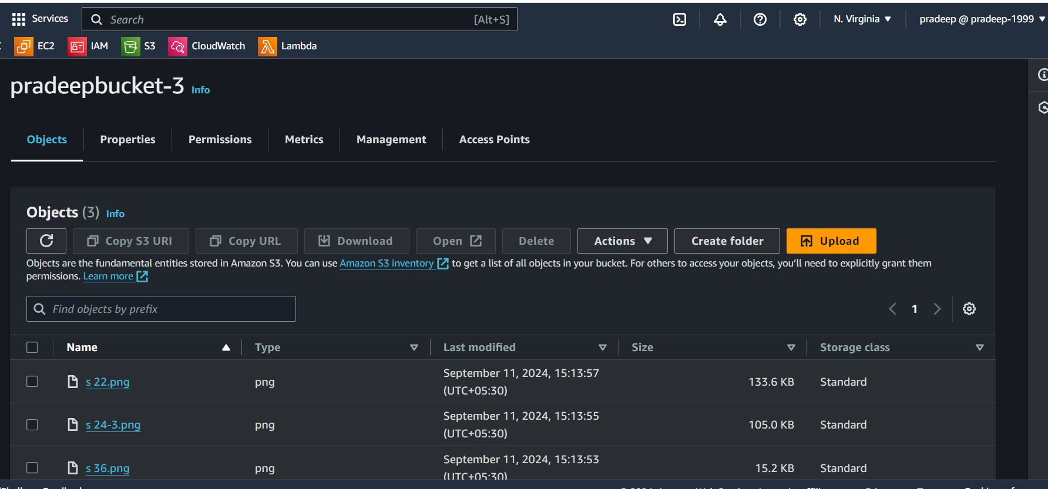

**45) Copy files from bucket-1(ap-south-1) to bucket-3(us-east-1).**

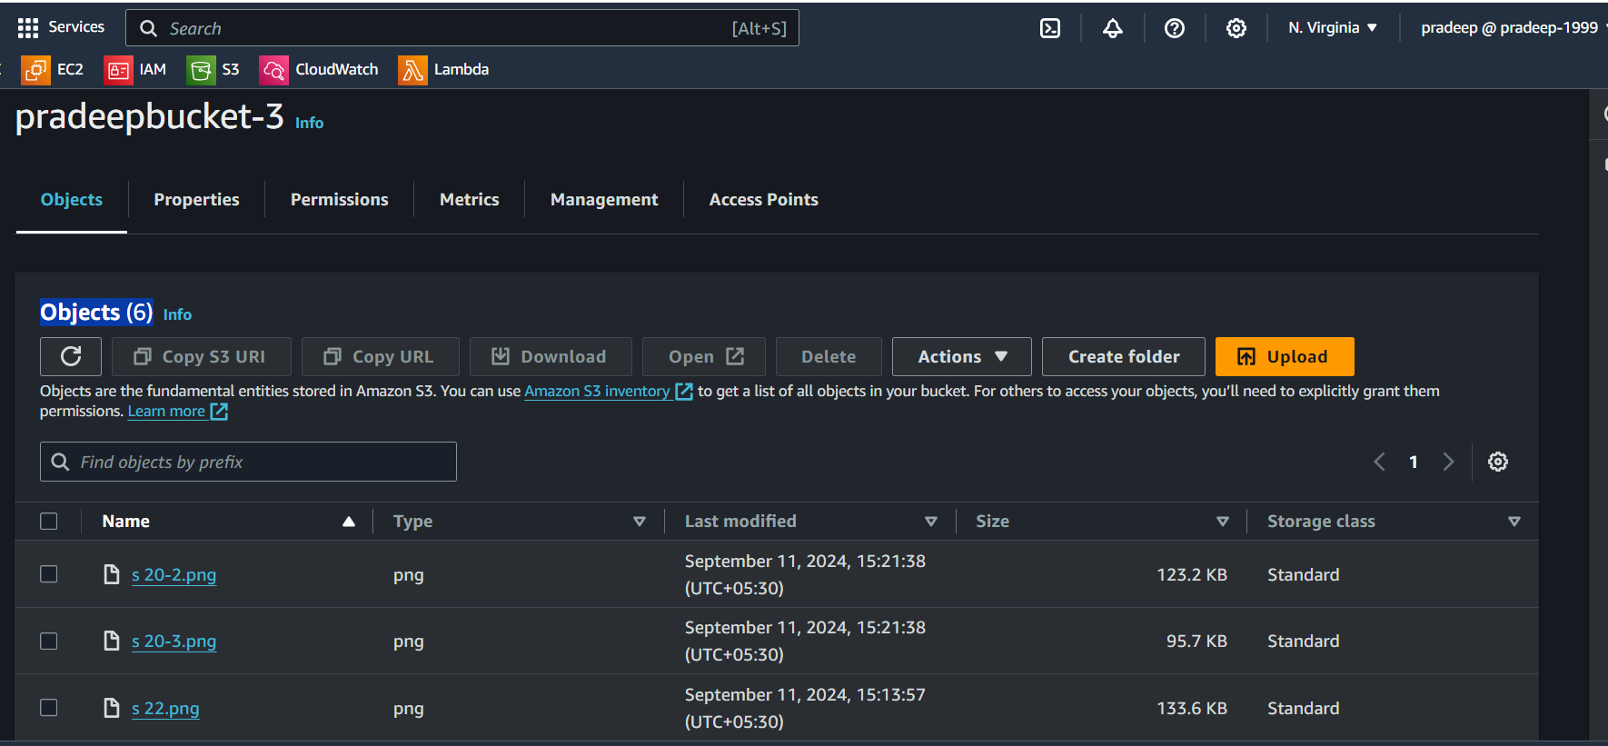

**46)Make bucket-1 as static webhost and add proper policy and change bucket acl's to get webpage - index.html**

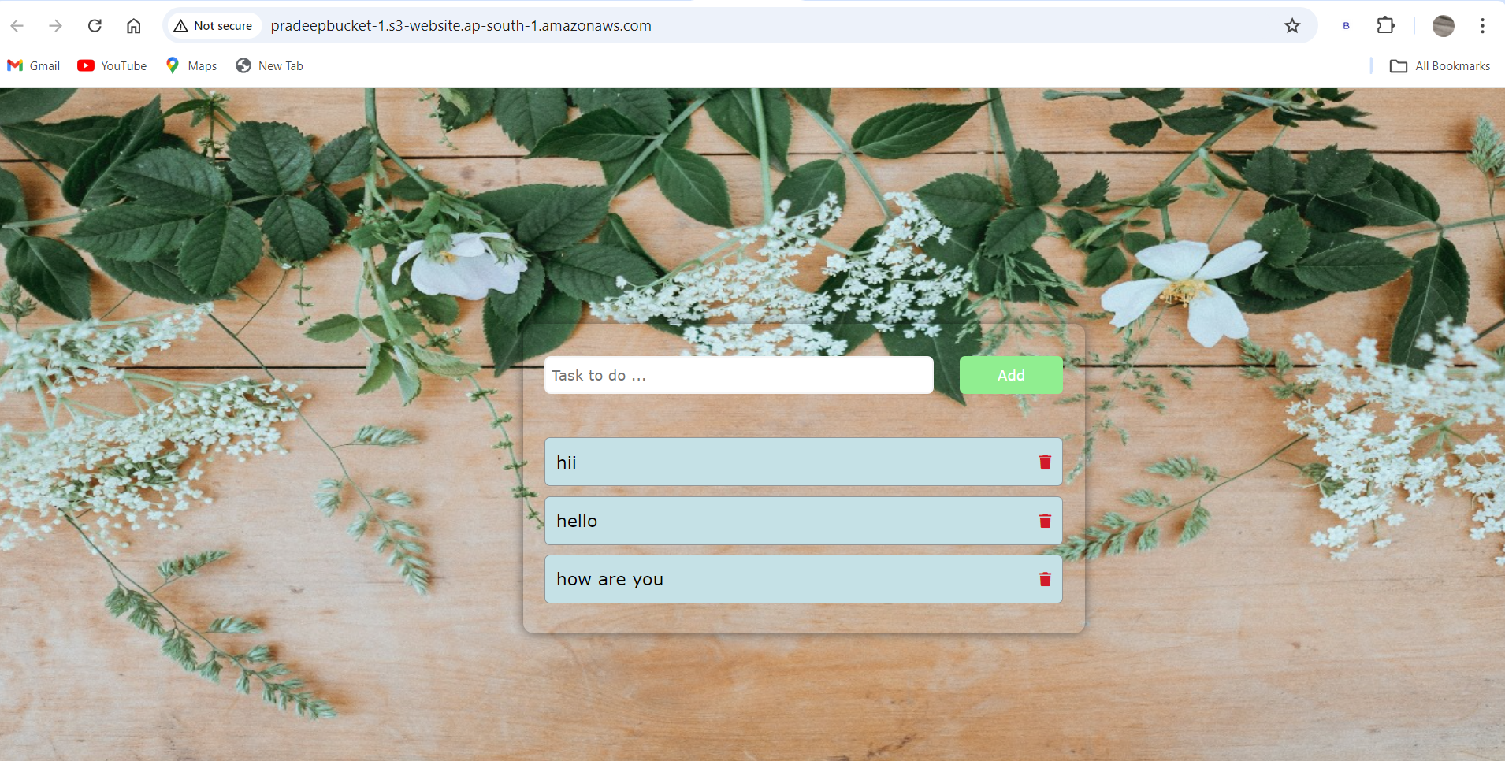

**47 Create ec2 instance in private subnet. Then access bucket-2 from created ec2 instance which is in private subnet**

**1)**

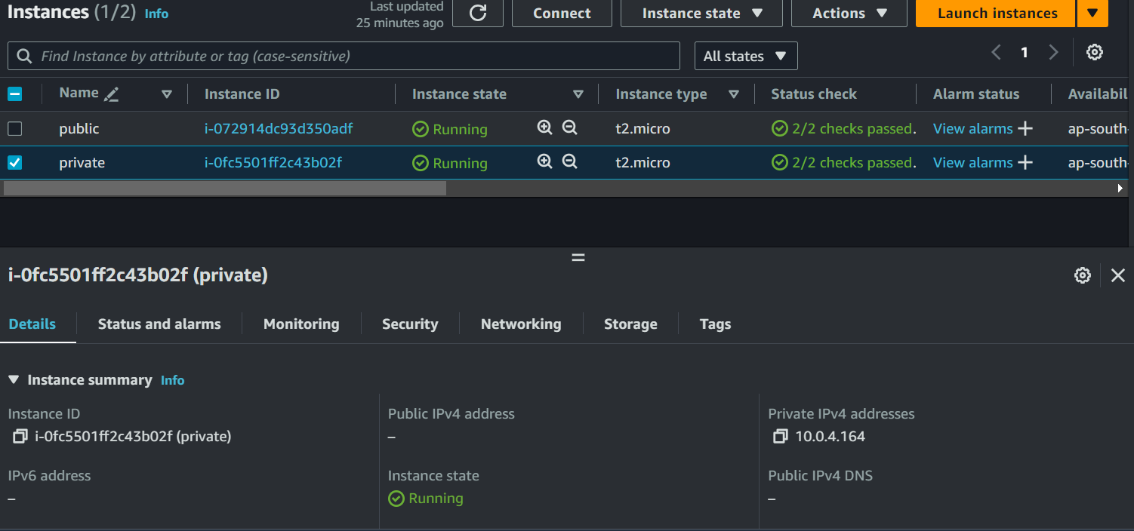

**2)** created role with **AmazonS3FullAccess** and attached the **IAM** role to the private instance

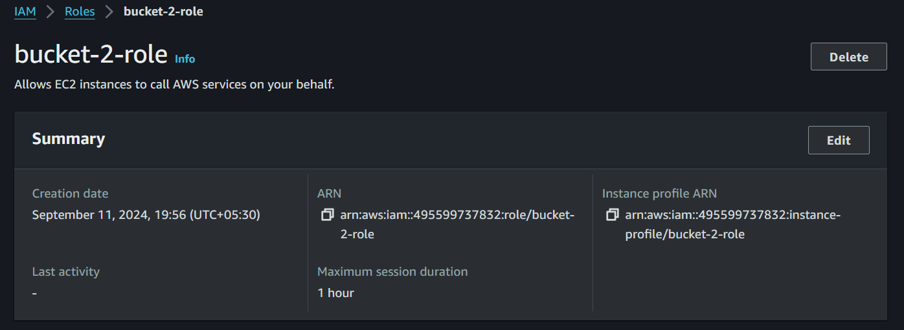

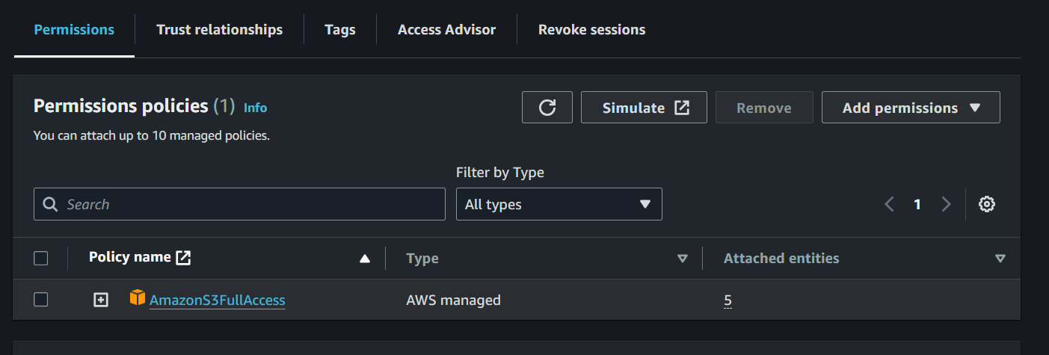

First access the instance with public subnet

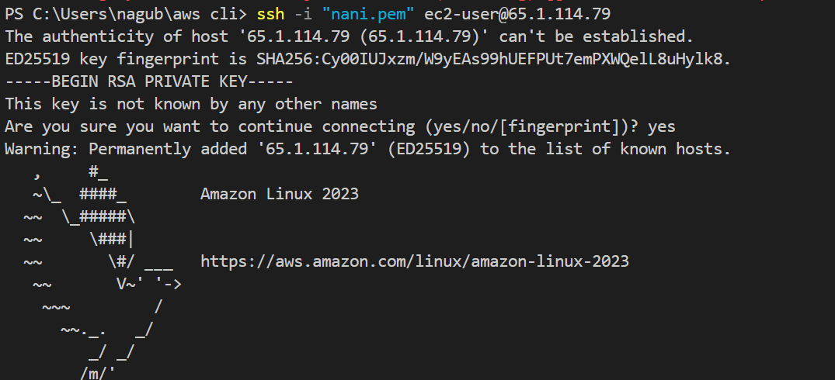

Next access the instance with private subnet and check the bucket-2 is accessed or not

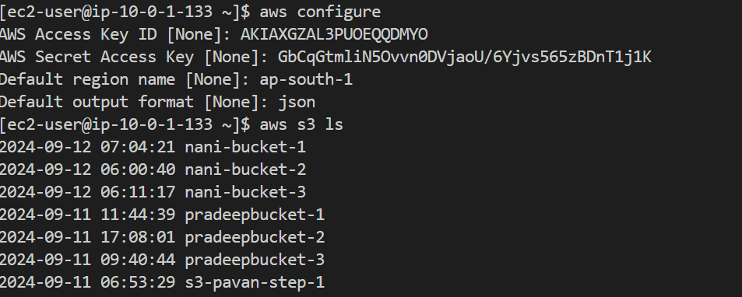

**48)Block one IP address on bucket-2**

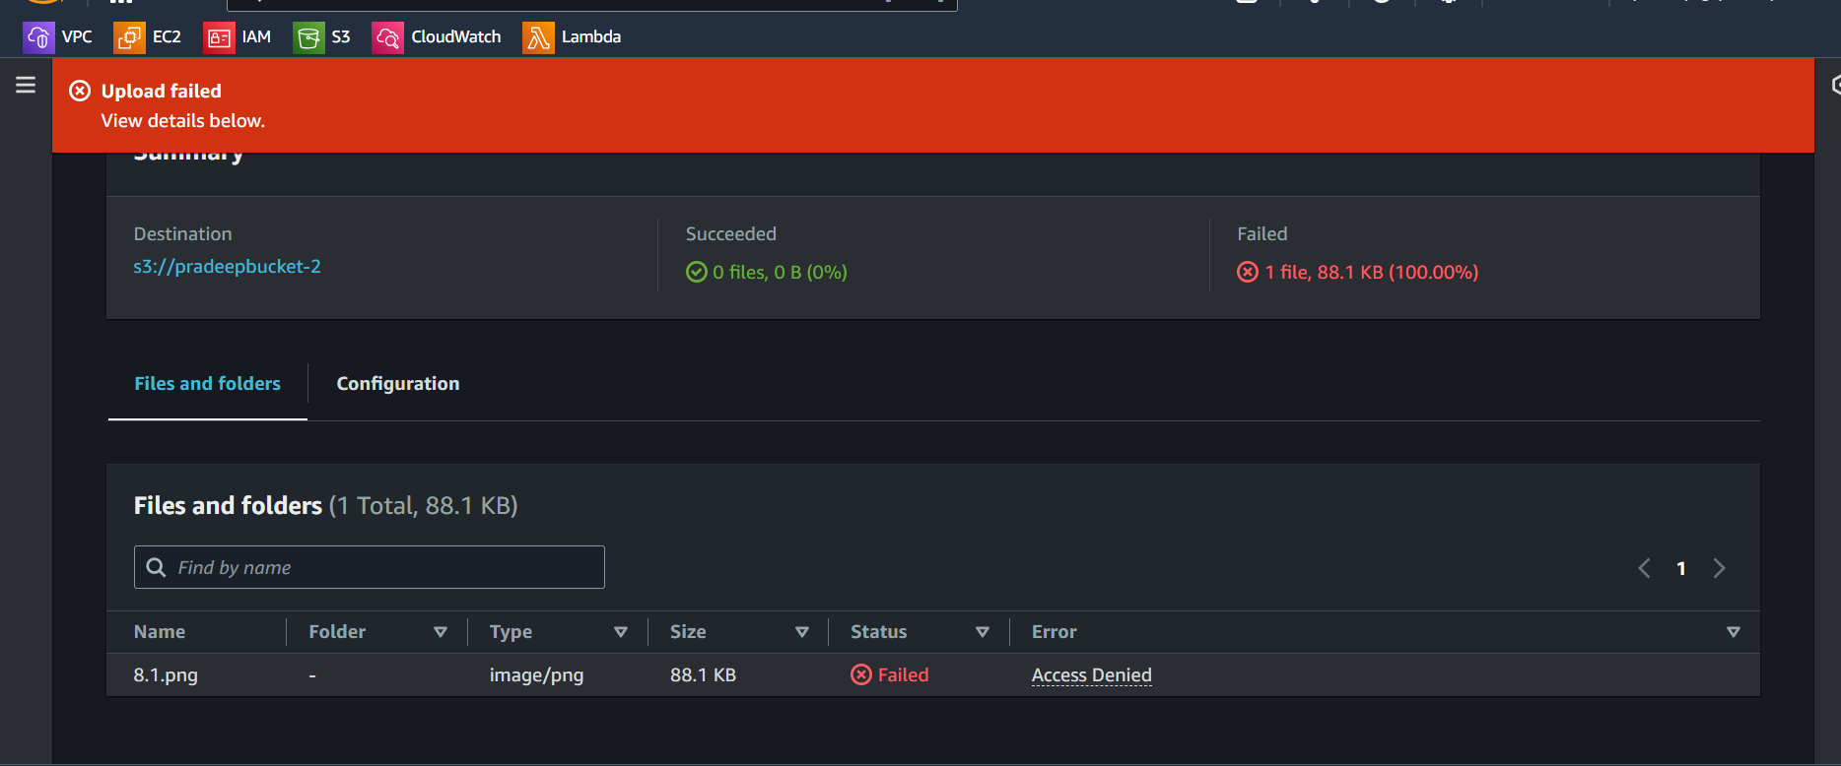

**49) Allow only one IP address on bucket-3**

